Effects of short-term restoration on plant-pollinator communities in Cantavieja and Ejea de los Caballeros

# Index

## Objectives

The objective of this report is to describe the differences between two plant-pollinator communities located in Cantavieja and Ejea de los Caballeros before and after restoration practices. In this report, we compare the two plant-pollinator communities using: 1) rarefaction analysis of the number of species and unique interactions; and 2) computation and evaluation of general aspects of network structure.

All data manipulation and analyses were conducted in R version 4.1.2 (R Core Team 2021).

## Sampling method

Two distinct locations were monitored with different historical land-use and management in the region of Aragón (Spain): Cantavieja (40º 30’ 44”, N 0º 22’ 59” W) at 1450m above sea level with a total of 30 plots and Ejea de los Caballeros (42º 01’ 06” N, 1º 08’ 53” W) at 350m. In each location, a total of 21 plots were monitored in 2021 and 2024. Plot size is 2m by 2m and they are randomly distributed within each location (see **Figure 1**). Importantly, since the start of the project vegetation has remained undisturbed without grazing or clearing.

Each plot was surveyed three times: at the begining of the season, at the peak of flowering and at the end of the season. In each occasion, all plant-pollinator interactions observed were documented. Pollinator specimens not identified in the field were captured and identified in the lab.

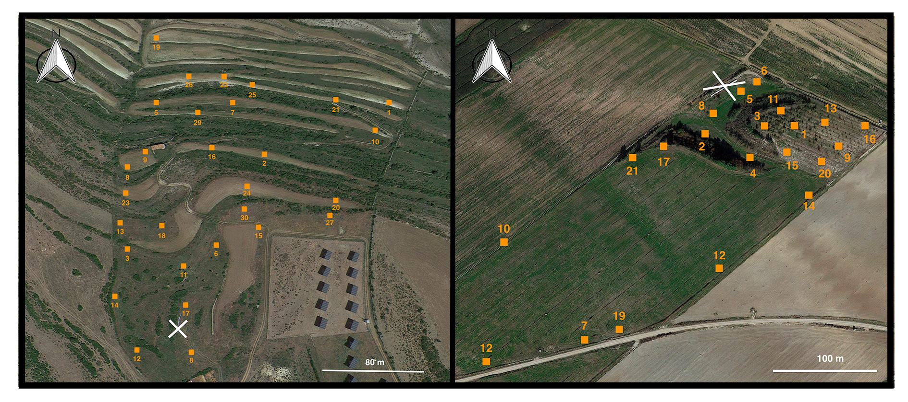

Cantavieja (left) and Ejea de los Caballeros (right) locations, with the different sampling plots indicated by an orange square along with the plot identifier. The positions of the bee hives are shown with a white cross in both locations.

## Comparative analysis

In this section, we focus on understanding how species richness and interactions change over time in both locations. Specifically, this section contains:

* 1. Rarefied accumulation curves of pollinator species and unique interactions per location and year to compare the number of observed species and interactions at equal number of sampling rounds (**Figures 2 and 3, respectively**).
  2. Comparison of plant and pollinator degree distributions per location and year (**Figure 4**).
  3. Comparison of plant and pollinator richness over time per location and year (**Figure 5**).

First, we observe that the rarefied accumulation curve of pollinators shows a non-saturating pattern, indicating that further sampling is needed to fully document the pollinator community of Cantavieja and Ejea de los Caballeros. The number of pollinators was higher in 2024 for both locations, but the difference was especially marked for Ejea de los Caballeros.

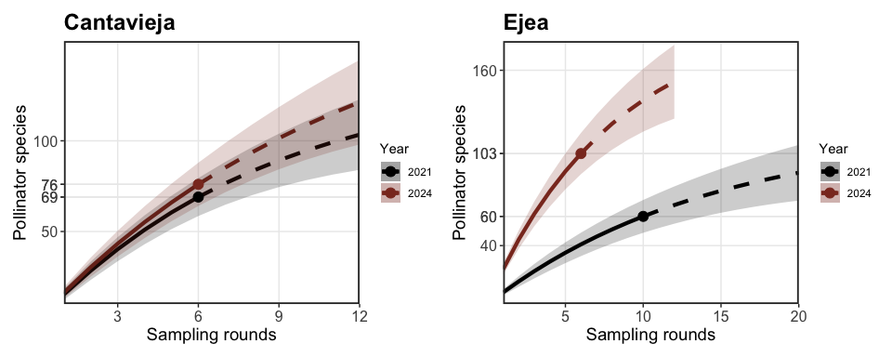

Rarefied species accumulation curves across sampling rounds in Cantavieja and Ejea de los Caballeros. The solid line indicates the rarefied number of species per sampling round, the dot represents the observed number of species, and the dashed line shows the extrapolated number of species if additional rounds were conducted.

Second, the rarefied accumulation curve of unique interactions was calculated for each location and year. Note that *Apis mellifera* was excluded, as their individuals do not directly respond to the applied restoration practices. An example of unique interaction is the visit of *Amegilla quadrifasciata* on *Eryngium campestre*, which was observed in both locations. Here, we observed similar patterns to the ones observed for the accumulation curve of pollinator species, where Cantavieja shows little differences between years but Ejea de los Caballeros shows notably more unique interactions for the year 2024.

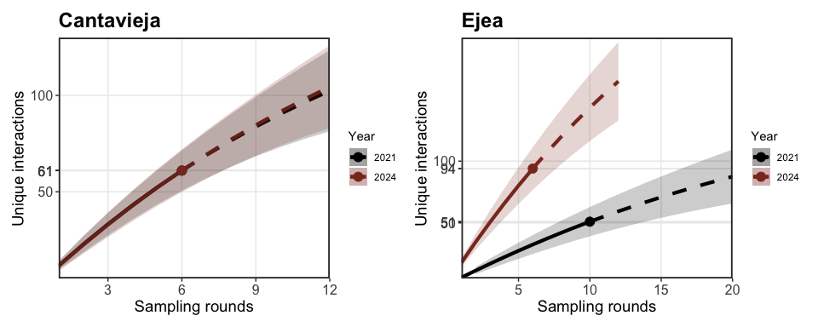

Comparison of the rarefied number of unique interactions across years in Cantavieja and Ejea de los Caballeros. Note that were excluded from this analysis.

Third, we compared the degree distributions between the pollinator and plant communities of Cantavieja and Ejea de los Caballeros across different years. Pollinators exhibited a classical decaying distribution for ecological networks (Jordano, Bascompte, and Olesen 2003), while plants had a more gradual decaying distribution. Pollinators did not show statistical differences between their distributions between years for both locations (Kruskal-Wallis *P* > 0.05). However, plants had statistically different distributions for both locations (Kruskal-Wallis *P* < 0.05). For plants, 2024 show a more even distribution of their interactions across plant species, indicating that the number of plants attracting many different pollinators has increased.

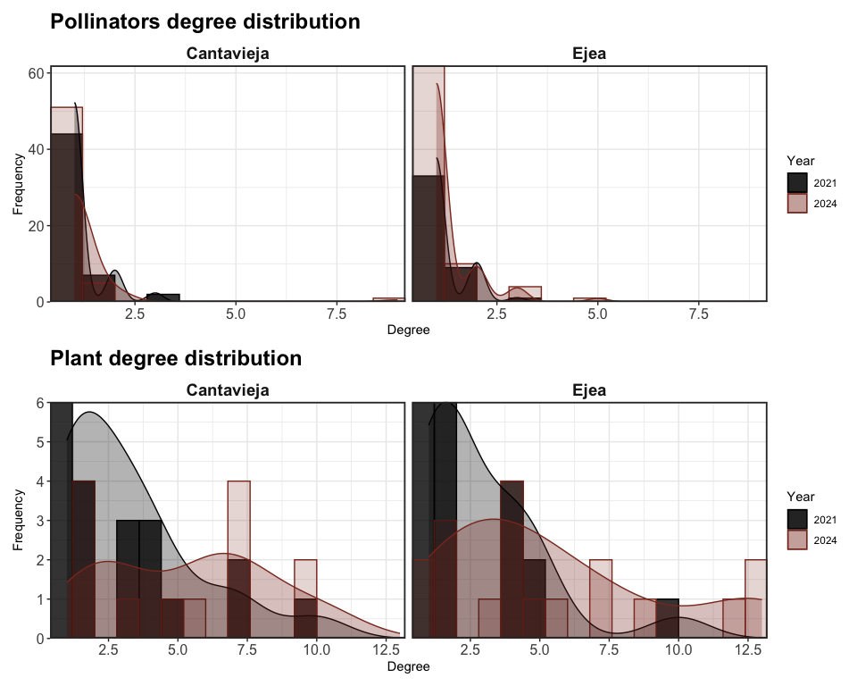

Comparison of the pollinator and plant degree distributions for Cantavieja and Ejea de los Caballeros between years.

Fourth, we evaluated how plant and pollinator richness changed over time. The number of observed pollinators, compared to plants, was higher on almost all sampling dates for both years. Ejea de los Caballeros showed notably higher pollinator richness across sampling dates in 2024 compared to the previous year while Cantavieja showed a similar pattern. Additionally, it is worth noting that the number of sampling days and the dates of sampling differed between the years.

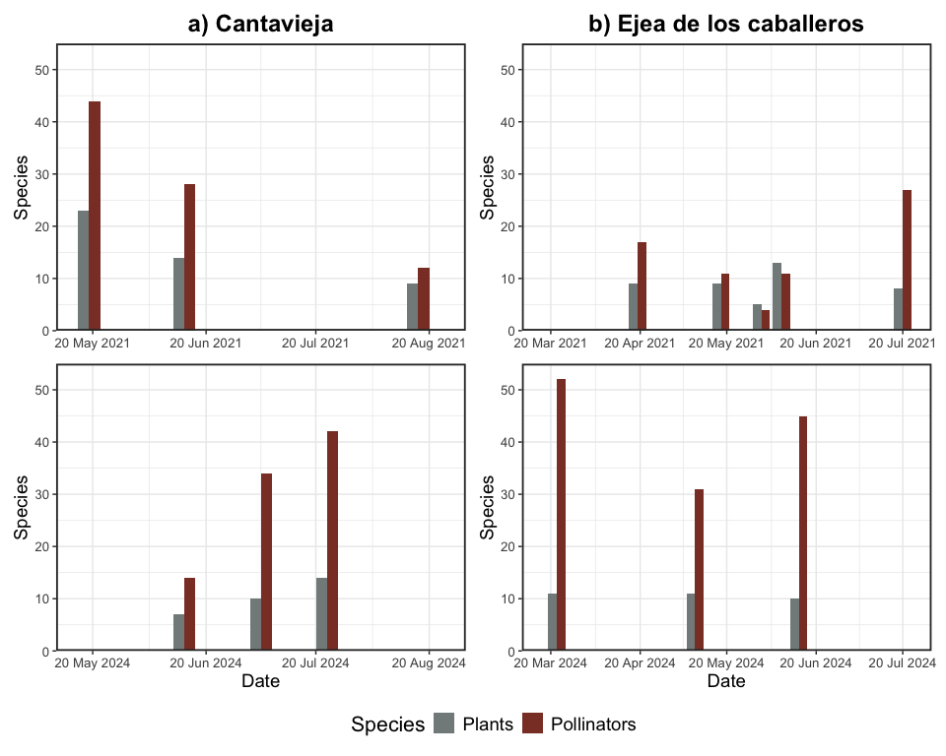

Comparison of the observed richness of plant and pollinator species per sampling date in Cantavieja and Ejea de los Caballeros for the years 2021 and 2024.

The structure of plant-pollinator networks per location and year was compared using the following network descriptors:

* 1. Network-level specialization (H2’), which indicates how selective the species are at the network level.
  2. Connectance, which refers to the number of links compared to all possible links.
  3. Robustness, which evaluates how resilient the network is to species loss.
  4. Nestedness, which describes how well the interactions of specialist species are subsets of those of generalist species.

Network-level specialization, connectance, and robustness were calculated using the *bipartite* package (Dormann, Gruber, and Fründ 2008). Note that for robustness, we evaluated the impact of excluding plant species, pollinator species, and excluding both. To compare nestedness across networks, we used a normalized metric (NODFc) that is independent of network size (Song, Rohr, and Saavedra 2017). This was implemented using the *Maxnodf* package (Hoeppke and Simmons 2021).

**Cantavieja**

Cantavieja had 69 pollinators and 29 plant species in 2021 and 76 pollinators and 19 plants in 2024. Note that these numbers include some individuals identified only to the genus level; however, they likely reflect distinct species, as there are generally no records of these genera (4 pollinators and 9 plants in 2021 and 5 pollinators and plants in 2025). The total number of recorded interactions was 130 in 2021 and 247 in 2024 (**Figure S6** for network comparisons). The level of network specialization was slightly higher in 2021 (H2’ = 0.56 than in 2024 (H2’ = 0.54), while connectance was notably higher in 2024 (C = 0.07) than in 2021 (C = 0.05). Robustness to plant loss was 0.51 in 2021 and 0.48 in 2024, robustness to pollinator loss was 0.68 in 2021 and 0.78 in 2024, and robustness at the network level was 0.37 in 2021 and 0.32 in 2024. Nomalized nestedness showed the opposite trend to network robustness, with 0.08 in 2021 and 0.14 in 2024. **Figure S8** and **Table 1** provide a summary of these findings.

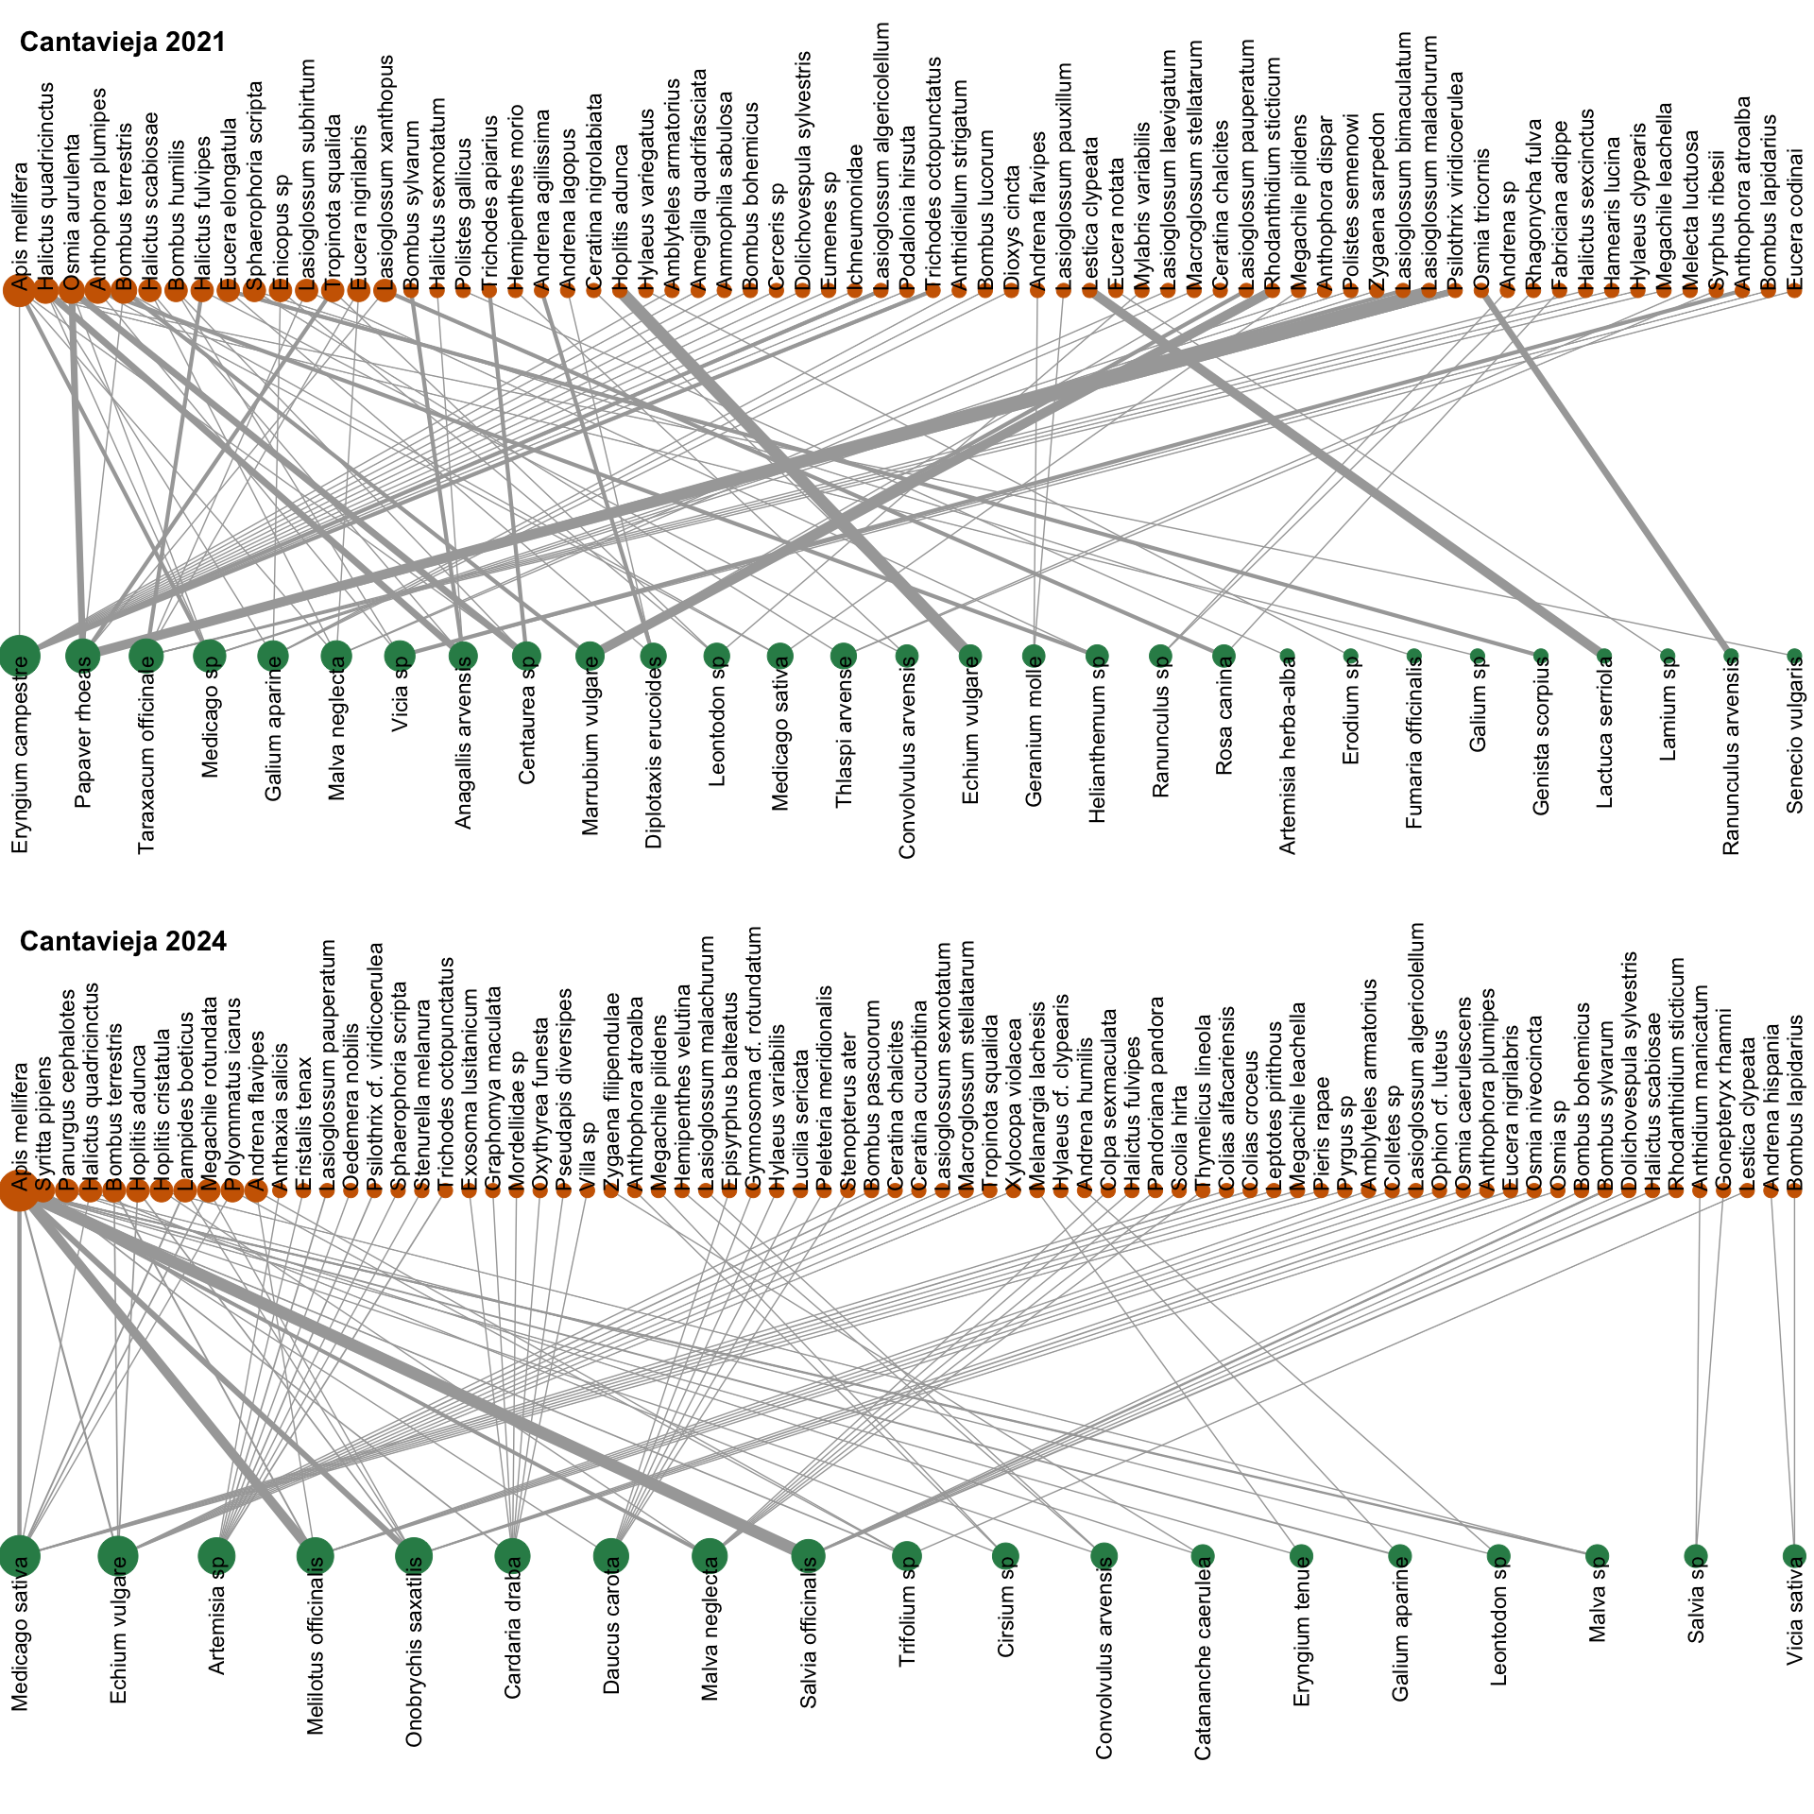

Bipartite plant-pollinator networks from Cantavieja. The top graph shows the network for the year 2021, while the bottom graph depicts the network for 2024, highlighting changes in species interactions and species composition between years.

**Ejea de los Caballeros**

Ejea de los Caballeros had 60 pollinators and 26 plant species in 2021 and 103 pollinators and 23 plants in 2024. Note that these numbers include some individuals identified only to the genus level; however, they likely reflect distinct species, as there are generally no records of these genera (7 pollinators and 6 plants 2021 and 12 pollinators and 5 plants in 2025). The total number of recorded interactions was 121 in 2021 and 187 in 2024 (**Figure S7** for network comparisons). The level of network specialization was slightly higher in 2021 (H2’ = 0.58 than in 2024 (H2’ = 0.52), while connectance was also slightly higher in 2024 (C = 0.06) than in 2021 (C = 0.05). Robustness to plant loss was 0.52 in 2021 and 0.51 in 2024, robustness to pollinator loss was 0.67 in 2021 and 0.79 in 2024, and robustness at the network level was 0.38 in 2021 and 0.32 in 2024. Nomalized nestedness showed the opposite trend to network robustness, with 0.09 in 2021 and 0.11 in 2024. **Figure S8** and **Table 1** provide a summary of these findings.

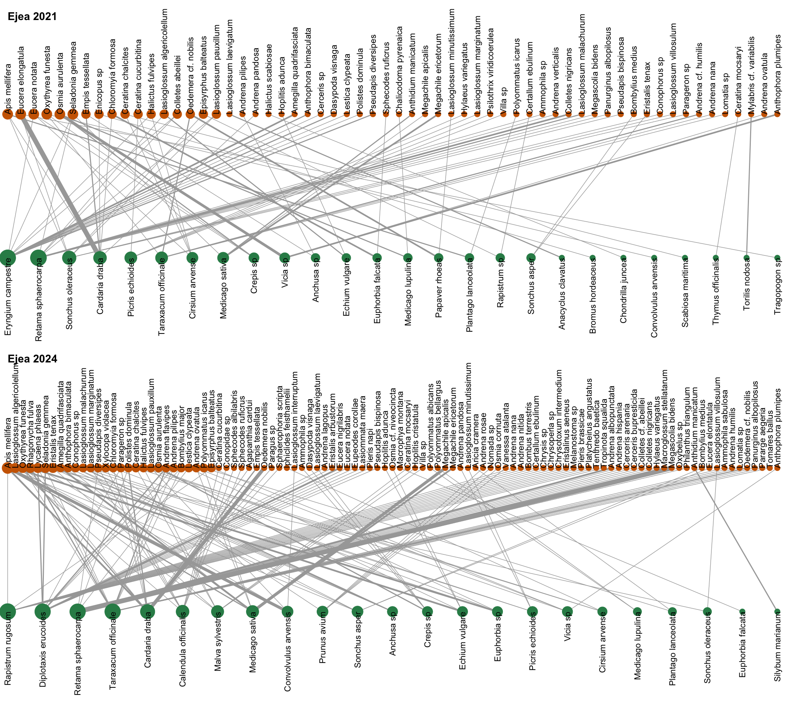

Bipartite plant-pollinator networks from Ejea de los Caballeros. The top graph shows the network for the year 2021, while the bottom graph depicts the network for 2024, highlighting changes in species interactions and species composition between years.

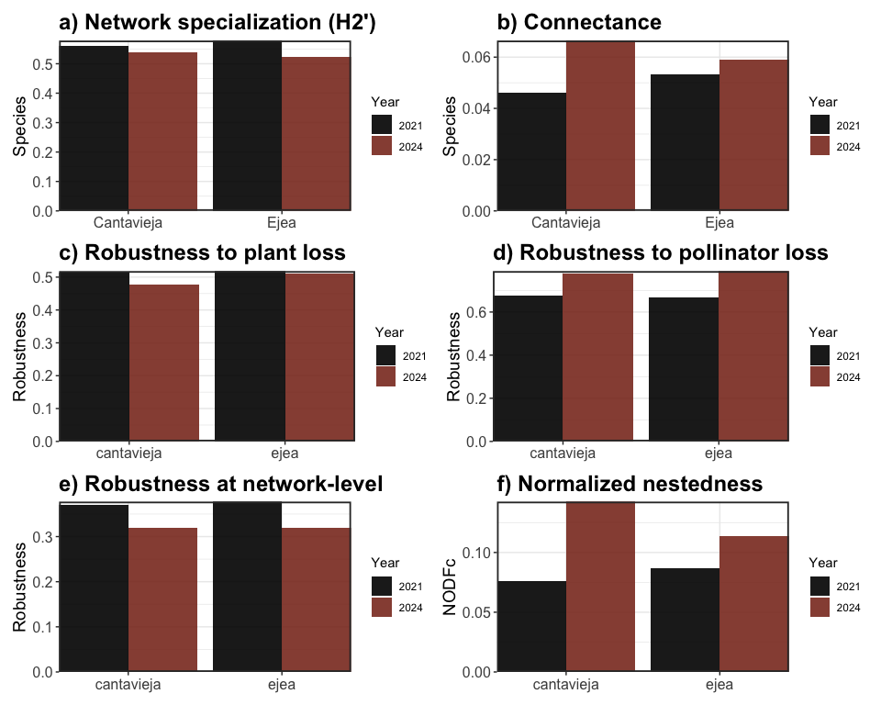

Comparison of network specialization (a), connectance (b), robustness to plant loss (c), robustness to pollinator loss (d), robustness at network level (e), and normalized nestedness (f) for Cantavieja and Ejea de los Caballeros across sampling years.

Our results show that plant-pollinator networks increased in connectance and degree of nestedness. These two properties are important because they are associated with the stability of the communities. In contrast, the networks did not change their degree of specialization, and the robustness to in silico extinctions showed mixed results, depending on which species went extinct, but with small effects in general.

## Concluding remarks

Overall, the total number of pollinators was higher after restoration practices along with key network descriptors such as connectance or normalized nestedness for both locations. However, it is worth noting that the accumulation curves of species richness and interactions does not saturate, likely indicating that further sampling effort to characterize the full plant-pollinator communities may be needed. The fact that sampling dates differed across years may affect the observed differences in plant and pollinator composition and interactions, as phenology is a key driver of plant-pollinator networks (Forrest 2015; Peralta et al. 2020). While robustness to pollinator loss was higher in 2024, the networks showed lower number of floral resources, which have important implications for the robustness of the overall networks, as the loss of few species can lead more rapidly to the loss of pollinators. The fact that networks are more connected and slightly less specialized in 2024 could be due to a lower plant:pollinator ratio, resulting in a higher number of partners per plant species, more connected networks and lower chances of being selective for pollinators. Thus, while restoration practices may have helped pollinator diversity, the level of sampling coverage and species phenology are key factors shaping these differences, and finer-scale data may be needed to uncover restoration effects.

## References

Dormann, Carsten F, Bernd Gruber, and Jochen Fründ. 2008. “Introducing the Bipartite Package: Analysing Ecological Networks.” *Interaction* 1 (0.2413793): 8–11.

Forrest, Jessica RK. 2015. “Plant–Pollinator Interactions and Phenological Change: What Can We Learn about Climate Impacts from Experiments and Observations?” *Oikos* 124 (1): 4–13.

Hoeppke, Christoph, and Benno I Simmons. 2021. “Maxnodf: An r Package for Fair and Fast Comparisons of Nestedness Between Networks.” *Methods in Ecology and Evolution* 12 (4): 580–85.

Jordano, Pedro, Jordi Bascompte, and Jens M Olesen. 2003. “Invariant Properties in Coevolutionary Networks of Plant–Animal Interactions.” *Ecology Letters* 6 (1): 69–81.

Peralta, Guadalupe, Diego P Vázquez, Natacha P Chacoff, Silvia B Lomáscolo, George LW Perry, and Jason M Tylianakis. 2020. “Trait Matching and Phenological Overlap Increase the Spatio-Temporal Stability and Functionality of Plant–Pollinator Interactions.” *Ecology Letters* 23 (7): 1107–16.

R Core Team. 2021. *R: A Language and Environment for Statistical Computing*. Vienna, Austria: R Foundation for Statistical Computing. <https://www.R-project.org/>.

Song, Chuliang, Rudolf P Rohr, and Serguei Saavedra. 2017. “Why Are Some Plant–Pollinator Networks More Nested Than Others?” *Journal of Animal Ecology* 86 (6): 1417–24.